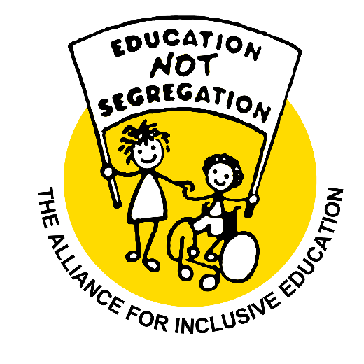

Alliance For Inclusive Education
(a charitable company limited by guarantee)

Report and Financial Statements

for the year ending 31st March 2025

Company number 05988026
Charity number 1124424

Table of Contents
Chair’s Report 2
Highlights of Our Work 4
2024/25 highlights 4
ACHIEVEMENTS AND PERFORMANCE 2024/25 7
Key Objective 1: Promote a wider understanding of the benefits of Inclusive Education for all. 7
Key Objective 2: Lead the lobby for change in legislation and policy to ensure inclusive education as a right for all. 8
Key Objective 3: Build the capacity of the inclusive education movement to become a more effective voice of influence. 10
Key Objective 4: Ensure maximum effectiveness of ALLFIE and its future sustainability. 11
Future Developments 12
Our Purposes and Activities 13
Objectives for the years 2025 – 2030 13
Our Finances 14
Income and Expenditure 2024-25 15
ANNEX 16
REPORT OF THE COUNCIL 16
STRUCTURE, GOVERNANCE AND MANAGEMENT 17
REFERENCE AND ADMINISTRATIVE INFORMATION 20
TRUSTEES’ RESPONSIBILITIES 20

Chair’s Report
This year has been another extremely busy year, with significant political change. It would not have escaped attention that there was a landslide victory for an incoming Labour administration, who have been hell bent on destroying hard won rights for many groups, including Disabled people. This has resulted in a deepening educational SEND crisis, and there is no indication of a resolution. At ALLFIE, we have continued to hold the government to account and asked difficult and critical questions that challenge their core ideological values. Such values are rooted in neoliberal government agendas that focus on market-driven cost cutting goals; goals that strip away social rights.
ALLFIE has successfully; responded to several government consultations, influenced policy, raised our voices via the media, engaged with our supporters and members, gathered a Coalition for Inclusive Education, and secured funding for our core work.
This work would not have been possible without the ALLFIE team and our Director, Michelle Daley, who has been instrumental in bringing together key groups. I am also grateful to our members and supporters who have been proactive in responding to calls for engagement. A major acknowledgement and thank you is also due to our funders, who have resourced us to do much of this important work.
We remain mindful of the work ahead of us; holding the government to account and questioning their ideologically driven goal of deepening the ongoing fragmentation of educational provision. This deepening educational fragmentation is out of line with international policy, is counter to the UNCRPD, and is at odds with the values and principles of Inclusive Education. Governments would do well if they heeded the advice as set out in General Comment Number 4 of the UNCRPD. UN Disability Committee noted, nearly a decade ago, that placing Disabled students within mainstream schools without appropriate support does not constitute inclusion, nor does creating discrete and isolated units. Specifically, it states that this ‘... cannot be defined as Inclusive Education’. As I have noted in earlier reports, it is our determination that we continue to pursue an Inclusive Education system in which all Disabled people are welcome, without question, period!
Navin Kikabhai
ALLFIE Chairperson

Highlights of Our Work
“We treasure ALLFIE, the beautiful gift crafted by you, Micheline, and other activists; the idea born at your kitchen table 30 plus years ago. ALLFIE has now grown to become the leading voice for Inclusive Education.” (A message from the ALLFIE team, 2025)
We start ALLFIE’s annual report 2024/25 by dedicating it to Micheline Mason. Stephen Hodgkins (ALLFIE’s Project Consultant) described Micheline in one of ALLFIE’s reflection meetings as an “architect”, and the mother of ALLFIE. She sadly passed away in September 2024. Micheline was an author, poet, artist, movement builder, and committed activist for Inclusive Education and wider social justice issues.
We are deeply grateful for Micheline’s pioneering work for ALLFIE, previously known as the Integration Alliance. Under Micheline’s initial direction and influence, ALLFIE’s work began to grow. It was alongside individuals such as Joe Whittaker (who later became ALLFIE’s Chairperson), an activist, academic scholar and educator, who introduced Inclusive Education and had been influenced by much of the work occurring in North America. It was soon after this that ALLFIE’s work adopted the language of Inclusive Education. As a Disabled parent of her Disabled daughter, Lucy, Micheline was also instrumental in founding Parents for Inclusion.
After her retirement, we were honoured that Micheline continued to engage with ALLFIE, offering valuable knowledge, conducting interviews, and participating in key events and meetings. For example, along with ALLFIE staff, she interviewed Judy Heumann for Inclusion Now magazine’s 60th edition. She also contributed to marking ALLFIE’s 30th Birthday.
Micheline and other fellow activists were instrumental in creating ALLFIE as an organisation that challenges educational segregation, and for this we are immensely grateful.

2024/25 highlights
We began the year by promoting our research into the lived experiences of Black/Global Majority Disabled pupils and their families. We shared the findings widely through articles, events, and social media. Our team spoke at events, contributed to publications, and continued to highlight systemic injustices in the education system.
In May 2024, then Prime Minister Rishi Sunak called a snap General Election for 4thJuly. With just over five weeks to prepare, ALLFIE shifted priorities to intensify its policy and campaign work. Our goal was to hold political parties accountable and to influence their manifestos. Activities included:
- 3 consultation meetings with staff, board members, ALLFIE members, stakeholders and ALLFIE’s Our Voice group.
- Publishing an analysis of the 4 main political parties.
- Producing and launching The Inclusive Education Manifesto 2024.
- Introduced free ALLFIE membership to make ALLFIE open to all and strengthen our membership.
- Participating in the writing of the Disabled People’s Organisation’s (DPO) Forum England Manifesto and joining Hustings.
It came as no surprise to the country that the Conservative Party lost the General Election, but the scale of their defeat was not expected. Labour was elected as the new government and immediately introduced a series of unexpected and deeply concerning proposals. These policy proposals threaten to undo many of the hard-won achievements of the Disabled People's Movement.
Among them are plans to cut disability benefits and to introduce new language to redefine “inclusion” in ways that are not aligned with Article 24 of the UNCRPD, which recognises Inclusive Education as a human right. As one of ALLFIE’s staff members stressed; “…the challenge we face right now is the definition of ‘inclusion’” (2025). This redefinition misleads the public and masks the government’s continued drive to expand segregation through units and schools.
At the time of writing this report, the government had passed the bill to make changes to disability benefits. Reports indicate that these cuts would affect 800,000 Disabled children, who will not be protected under these changes. In addition, the Terminally Ill Adults (End of Life) Bill, led by Labour MP Kim Leadbeater, has been passed. This effectively legalises assisted suicide in England and Wales raising concerns about potential changes to medical and the safeguards in place for Disabled people.
There are also reports that the government is proposing to change SEND provision, including scrapping EHCPs. ALLFIE has published a briefing on this development.
This government’s actions will be remembered as a deeply sad moment in our history, and both reflect and reinforce systemic attitudes and policies that pose significant risks of harm to Disabled people.
ALLFIE continues to influence policy by responding to the government’s consultations, which are a vital means to hold those in power to account and gather evidence to shape our campaigns. For example, our submission to the Education Select Committee inquiry on Solving the SEND Crisis, Curriculum and Assessment Review, and the consultation on Disabled Children’s Social Care, offered strong arguments for systemic change. This allowed us to capture the voices of Disabled people, parents and professionals who are passionate about Inclusive Education and ending all forms of segregation. One exciting area of work involved exploring the creation of a Youth Parliamentary Group. While we researched national and international models, we were disappointed to find no group free from ableist entry assessments and we are continuing to look at ways to set up an accessible group.
We strengthened our digital presence, delivered training and workshops, engaged in public speaking, and supported the growth of the Inclusive Education movement. Some highlights included:
- In August 2024, we provided a narrative for Equal Play, a Channel 4 documentary on inclusive sport.
- In March 2025, we joined Disabled People Against Cut’s (DPAC) ‘Disability benefits cuts National Day of Action’ to draw attention to issues in the education system. This protest was reported to have 2,000 people present. We were interviewed by BBC News online, and our coverage continues to be featured across multiple platforms in 2025.
- We implemented the Coalition for Inclusive Education presentations as resources on our YouTube channel.
- In collaboration with organisations such as Lambeth Parent Forum and Contact, we deepened our understanding of systemic barriers within the education system for Disabled children and their families.
- We launched a dedicated ‘Our Voice’ project page and produced a photo blog showcasing youth engagement.
- We held regular steering group meetings with London-based DPO’s, covering key topics such as; creating systemic change through lived experience, advocacy and other tools, engaging with ALLFIE's education manifesto, and collaborating with Young Disabled people through DPOs.
We continued to develop our work; to invest in staff wellbeing and collaborative practices, to support shared learning and to smoothly transition into our new organisational structure. Each ALLFIE team member was allocated a budget for them to carry out training and receive mentoring.
ALLFIE increased income and staffing levels, improving long-term commitment to deliver on the organisation's visions. We began a small project to diversify our income generation and fundraising strategy, which is due to be completed in 2025. This work will build internal capacity to fundraise for additional work around leadership development.
Looking ahead, we have secured £300,000 over three years, with funding from The Clothworkers’ Foundation, through their Disability Equity Programme. ALLFIE is the first DPO to be funded under this new initiative.
In a world designed to exclude Disabled people, your commitment is an act of power and solidarity. Because of our volunteers, members of staff, board of trustees, supporters, members, allies, donors, and grant partners, we keep pushing forward to disrupt the systemic structures and systems of oppression within the education system.
For collective liberation we say, “educate - don’t segregate”
One Love,
Michelle Daley
ALLFIE Director

ACHIEVEMENTS AND PERFORMANCE 2024/25

Key Objective 1: Promote a wider understanding of the benefits of Inclusive Education for all.
“Our agenda is to introduce a law on Inclusive Education.” (ALLFIE Staff, 2025)
We continue to engage in a diverse range of activities to promote a wider understanding of the benefits of Inclusive Education as both a right and a social justice issue. ALLFIE is working to drive Inclusive Education by; launching the Coalition of Inclusive Education, increasing member engagement, and establishing strategic collaborations. These efforts have collectively created new opportunities to raise awareness around the social injustices Disabled people experience within the education system.
We also continue to engage with international organisations. For example, our collaboration with the European Network on Independent Living (ENIL) included interviews with their volunteers on Inclusive Education. Through our capacity building work, we continue to build on our outreach efforts, including a meeting with Jonny Uttley, CEO of a group of 12 Academy schools in Northern England. Additionally, we continue to deepen our work with parent organisations such as Lambeth Parent Forum and Contact.
Examples of some of our engagement work includes:
- Attending the Royal Society of Art’s event on Preventing School Exclusion. We highlighted the absence of Disabled students in mainstream exclusion policies. The event was attended by over 100 people, both virtually and in person.
- Presenting at the University of East London, as part of a Disability History Month (DHM) event.
- Attending 3 lectures, including “Doing Inclusive Education Differently" by Prof Tim Corcoram from Deakin University in Melbourne, Australia
- Delivering a lecture on Inclusive Education at the University of Manchester attended by 10 people.
- Engaging with Inclusion London on their Hate Crime project.
- Engaging with 2 parents of Disabled children as part of ALLFIE’s End Torture Campaign
- Publishing 23 e-bulletins with 10,265 opens 7 YouTube videos with 828 views, 3 editions of Inclusion Now Magazine, 3 inclusion resources, 2 blogs, 5 briefings, 4 letters to Ministers, and 1 tribute page. This included a photo blog on the Our Voice summer event https://www.allfie.org.uk/news/blog/our-voice-projects-in-person-event/.
- Growing our social media engagement, including launching accounts on Bluesky and Linktree digital media platforms
- Attending 16 conferences / workshops, including ‘Exploring Carceral Intersections of Race, Class and Disability’, and a session on early years education entitlements and SEND, which enabled ALLFIE to reach over 3,000 people.
- Attending a School Inclusion Project policy meeting at Garden Court Chambers.

Key Objective 2: Lead the lobby for change in legislation and policy to ensure inclusive education as a right for all.
“We came together to polish up the manifesto then we worked together as a team to work on consultations.” (ALLFIE staff, 2025)
We sustained a high level of visibility through our policy, research, consultation responses, stakeholder engagement, and campaign work. Our influence remains strong, maintaining our position as the only DPO in the UK solely focused on Inclusive Education as a human right and social justice issue.
Our research and policy work has been influential, particularly the Lived Experiences of Black/Global Majority Pupils and Families research report, was referenced in the Children’s Rights Alliance for England (CRAE) shadow report to the UN CERD Committee, where it received significant attention. The research was also shared through two published articles and a presentation to staff at the Runnymede Trust. Additionally, we contributed to CRAE’s Children’s Rights Charter for the General Election.
As part of our youth parliamentary work, we also produced a mini report on the different youth parliamentary models. ALLFIE’s written evidence to the Education Committee’s inquiry on solving the SEND Crisis was published and can be accessed here: https://committees.parliament.uk/writtenevidence/135938/html/

Example of key activities include:

Parliamentary and National Policy Engagement
- We submitted a response to the NAO’s Value for Money inquiry on the Department for Education’s (DfE) support for children and Young people with SEND and those in alternative provision. Our contribution was recognised in the final report published by the NAO (https://www.nao.org.uk/reports/support-for-children-and-Young-people-with-special-educational-needs/).
- We published a briefing on the 2025 King’s speech, highlighting its potential impact on Disabled students.
- We raised serious concerns about plans by the education watchdog to reform the way it inspects and assesses schools, as featured in this Disability News Service article: Ofsted’s plans to reform inspections ‘will continue to enable discrimination’

- Consultation key submissions
  - Improving the Curriculum and Assessment system.
  - Law Commission’s consultation on Disabled Children’s Social Care.
  - Education Committee’s major inquiry on "Solving the SEND Crisis".
  - Poverty Taskforce (on behalf of Save the Children – National Poverty Task Force) focus groups with:
    - 10 Young people
    - 8 parents of Disabled Children
These workshops drew interest from over 100 people and offered valuable learning opportunities.
- Ministerial Engagement key activities:
  - We attended the Council for Disabled Children (CDC) SEND Joint Ministerial Roundtable meetings.
  - We participated in the Ministerial Roundtable with Minister for School Standards, Catherine McKinnel MP, calling for alignment with CRPD General Comment No. 4 on Inclusive Education.
  - We had multiple meetings with DfE officials regarding systemic issues such as accessibility, and the need for a statutory definition of Inclusive Education.

- MP Engagements and APPG:

  - We met with MP Steve Darling (Liberal Democrats, Torbay), who agreed to support ALLFIE’s work and to be involved in a proposed All-Party Parliamentary Group (APPG) on Inclusive Education.
  - We held a meeting with the Mayor of Hackney Council, GLA, Lambeth Council, and the office of Baroness Grey-Thompson.

Campaigns and Public Engagement
- We attended a follow-up briefing on Disability Rights and (Anti-) Torture discussion as part of our work on End Torture.
- We attended both the National Disability Hustings in Manchester, and the National DPO England Hustings, where our question on the Children and Families Act was raised.
- We published our manifesto and a political analysis of the 4 main political parties in the lead up to the General Election 2024.
- We actively supported and participated in DPAC’s National Day of Action on the benefit cuts, such as:
  - We attended the benefit meeting at Portcullis House, where ALLFIE was acknowledged as a supporting DPO.

Key Objective 3: Build the capacity of the inclusive education movement to become a more effective voice of influence.
“When I look back at the year, we’ve done quite a lot of sessions on different stuff -where we’re drawing on our own experiences and helping other people draw on their own experiences… But helping people have a voice in different ways, have that conversation in different ways, and creating space because I think, often, they don’t get that opportunity” (ALLFIE staff member, 2025).
ALLFIE continues to build capacity, both internally and externally, through a wide array of activities covering communication, legal empowerment, partnership with parents of Disabled children and youth led organisations, and collaborative campaigning rooted in intersectional justice. We have also partnered with Inclusion London (the lead partner) over a 2-year period on a new Future Movement Builders project. Our intention is to support leadership and employment opportunities for Young Disabled people. While preparation work started in 2024, the direct engagement with Young people began in 2025.
Our digital presence and communications raised awareness and informed communities. We published 3 impactful editions of Inclusion Now magazine, featuring articles written by ALLFIE staff, including a tribute to Micheline Mason, ALLFIE’s founder. The renowned cartoonist, Crippen, contributed illustrations, improving the presentation of the magazine.
We also published a legal signposting resource as part of our rights-based capacity building materials and our commitment to the liberation of Disabled people.
Despite delays in redeveloping our website due to issues with the consultant, we have taken proactive steps to move this work forward. This includes meetings with Banana Design and the development of a plan to go live in 2025 - 2026.
We also developed the ‘Our Voice’ project page and produced a photo blog showcasing our youth engagement activities. As mentioned above, ALLFIE provided the narrative for the Equal Play Channel 4 documentary, which was televised in August 2024. As part of our involvement in the documentary we were invited to attend the Paralympics Social Impact Reception in Paris. Lisa Nandy MP, Secretary of State for Culture, Media and Sport, gave a speech at the event, highlighting a commitment to inclusive sports for Disabled people. Our work received media coverage from the Disability News Service, further amplifying our message and building the capacity for an Inclusive Education movement.
Key presentations from the Coalition for Inclusive Education were developed into resources and made available via our YouTube channel, as part of our ongoing capacity building work.
Additionally, we hosted a well-attended and engaging annual conference marking 10 years of the Children and Families Act. The event featured a keynote by Steve Broach KC, and a presentation by our Policy and Research Lead, Edmore Masendeke. The event attracted over 50 people, and a recording of the event is available on our YouTube Channel.

Examples of key activities:
- We developed a new Legal Support and Representation page on our website: https://www.allfie.org.uk/further-information-and-support/
- We maintained digital outreach including:
  - Regular blog posts.
  - Solidarity tweets with sibling DPOs, such as Inclusion London and DPAC.
  - Digital research, policy and campaigns work.

- We collaborated with Lambeth Parent Forum and Contact to deliver a series of 3 training sessions (2 online, 1 in-person). We engaged with 50 parents of Disabled children.
- We held 8 steering group meetings and 3 Stronger Voices meetings, maintaining regular gatherings.
- We expanded outreach to key groups, such as: Youth Sport Trust, Embrace Wigan, Snowdown Trust, DSAuk, Wheelpower, YMCA, and Clement James Centre.
- We delivered training to groups, such as DEWA and One Place East.
- Hosted four ‘Our Voice’ themed meetings, which focused on: music, activism, and the school-to-employment transition.
- We participated in an interview for UCL.
- We participated in the Eugenics Legacy Education Project (ELEP) research project.

Key Objective 4: Ensure maximum effectiveness of ALLFIE and its future sustainability.
“I’ve learned how to use the new systems myself that makes the workflow easy for the organisation” (ALLFIE staff member)
ALLFIE remains committed to improving our efficacy and ensuring long term sustainability, so we can thrive as the leading DPO for Inclusive Education.
To ensure our continued impact, we implemented a new organisational structure, introducing lead and co-lead roles to share accountability and responsibilities. Our staff team continues to grow; we recruited 2 new members of staff, a Social Media Co-lead and an Events and Admin Co-lead.
We have improved operations by implementing Bright HR, reviewing internal policies, and are currently preparing to publish our revised organisational strategy in 2025.
In terms of staff well-being, we now offer mentoring for all staff and allocated training budget to each staff. Our supporters and volunteers play a vital role in shaping various aspects of our work such as:
- Contributing to the Inclusion Now Editorial board, assisting with editorial review and providing lived experience or subject matter input.
- Supporting research and policy development, such as consultations.
- Liberating Young Disabled people’s activism.
In addition to the £50,000 funding we received from the Joseph Rowntree Charitable Trust, we secured:
- £8,000 from the Esmée Fairbairn Foundation (Funding Plus) for developing fundraising training and strategy.
- £100,000 from the Paul Hamlyn Foundation, as a follow-on grant for ‘Our Voice’ Youth work.
- £300,000 from Clothworkers, for the implementation of our revised strategy.

Our continued grant funding includes:
- The Esmée Fairbairn Foundation – £205,700 over two years;
- The Joseph Rowntree Charitable Trust – £198,000 over three years;
- Trust for London – Disability Justice Fund – £98,250 over three years;
- Trust for London – Stronger Voices – £165,000 over three years;
- The Paul Hamlyn Foundation – £96,000 over two years.
We also generate income through consultancy, public speaking engagements, and donations.

Future Developments

In the year 2025/2026 we will:
- Explore the formal establishment of an ALLFIE-led All-Party Parliamentary Groups (APPG) on Inclusive Education.
- Develop capacity building training for the parents of Disabled Children.
- Deliver a series of legal capacity building Strategic Litigation workshops.
- Deliver Disability Justice movement-building workshops for targeted audiences.
- Engage in post-election policy influence, monitoring and campaign activities.
- Implement the Clothworkers grant to support ALLFIE’s revised strategy.
- Embed ALLFIE’s new organisational structure.
- Launch and publish legal capacity building podcast series.
- Launch ALLFIE’s revised website.
- Publish capacity building consolidation resources.
- Publish findings from the Coalition for Inclusive Education.
- Publish ALLFIE’s revised organisational strategy.
- Expand ‘Our Voice’s’ group membership.

Our Purposes and Activities
The objectives of the charity are to advance for the public benefit, irrespective of (physical, sensory, intellectual or emotional) impairment, age, gender, race, belief/religion, sexuality, social status, and any other protected characteristic, the ending of segregation of Disabled pupils/students and those categorised as having ‘special educational needs’ from the mainstream education system in the UK. ALLFIE aims to uphold and achieve the right to the education and inclusion of all learners within fully resourced, mainstream educational settings.
Our main activity continues to be lobbying for changes to legislation, policy and practice that discriminates against Disabled pupils/students and prevents inclusion, including for individuals labelled with SEN. This involves campaigning work, capacity building with individuals and groups to create change at a grassroots level, training and information sharing, fundraising for the core budget, and engaging in new projects.

Objectives for the years 2025 – 2030
- Lead the lobby for change in legislation and policy to ensure inclusive education as a right for all.
- Promote a wider understanding of the benefits of inclusive education for all.
- Build the capacity of the inclusive education movement to become a more effective voice of influence.
- Ensure the maximum effectiveness of ALLFIE and its future sustainability.

Our Finances
Statement of Financial Activities (incorporating the Income and Expenditure Account)
For the year ended 31ST MARCH 2025
INCOME AND EXPENDITURE  INCOME: |  | 2025  £  Unrestricted | 2025  £  Restricted | 2025  £  Total | 2024  £  Total
Donations, Grants and legacies |  | 202,770 | 188,000 | 390,770 | 255,338
Other Income from charitable activities and Bank Interest |  | 13,758 | 4,189 | 17,947 | 20,534
Total Income |  | 216,528 | 192,189 | 408,717 | 275,872
EXPENDITURE:
Expenditure on charitable activities
Capacity building and campaigns |  | 174,251 | 150,908 | 325,159 | 211,807
Net Income/(expenditure) |  | 42,277 | 41,281 | 83,558 | 64,065
Reconciliation of funds:
Total funds brought forward |  | 124,410 | 11,869 | 136,279 | 72,215
Total funds carried forward |  | 166,687 | 53,150 | 219,837 | 136,279

The statement of financial activities includes all gains and losses recognised in the year. All income and expenditure derive from continuing activities.

Income and Expenditure 2024-25

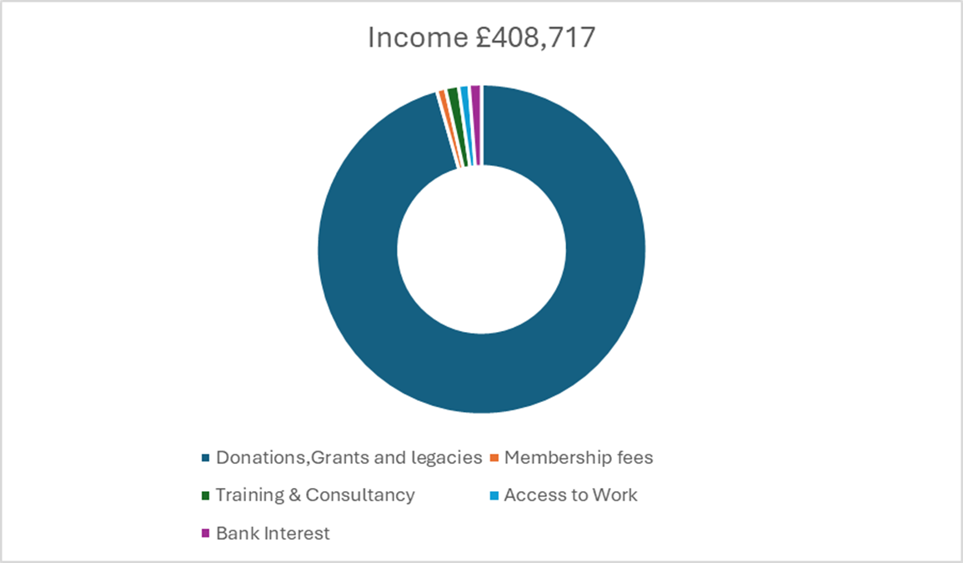
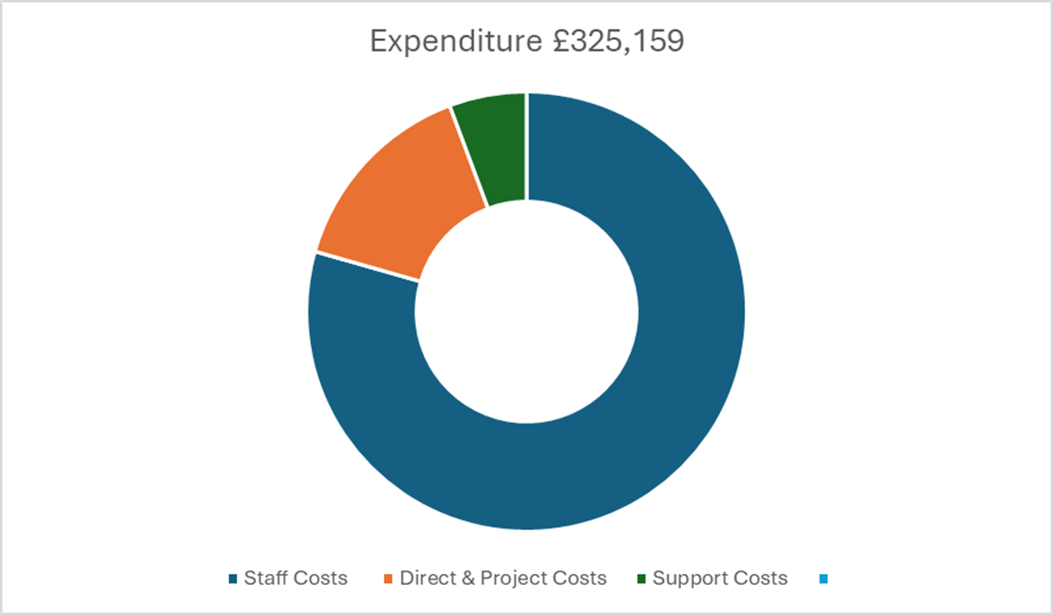

ANNEX
ALLFIE remains committed to our vision for an inclusive education, to move towards an inclusive society for all. We know that our goal can only be achieved through the support and dedication of stakeholders, allies, partners, donors and funders. During the year, you have supported ALLFIE to continue to raise our profile, engage new voices and strengthen our campaign to tackle disability inequality in education.

REPORT OF THE COUNCIL
Alliance for Inclusive Education Council members (who are trustees for the purposes of charity law) present their report along with the financial statements of the charity for the year ending 31st March 2024. This report also constitutes a Directors’ report as required by the Companies Act 2006 and has been prepared taking advantage of the exemptions conferred by Part 15 of this Act.
The financial statements comply with the Charities Act 2011, the Companies Act 2006, the Memorandum & Articles of Association, and Accounting and Reporting by Charities: Statement of Recommended Practice applicable to charities preparing their accounts in accordance with the Financial Reporting Standard applicable in the UK and Republic of Ireland (FRS 102) (effective 1 January 2015). The company has taken advantage of the exemption to not have to prepare a strategic report in accordance with “The Companies Act 2006 (Strategic Report and Directors’ Report) Regulations 2013”.

Public benefit
The Charities Commission in its ‘Charities and Public Benefit’ guidance requires that two key principles be met in order to show that an organisation’s aims are for the public benefit: first, there must be an identifiable benefit and second, the benefit must be to the public or a section of the public. The Trustees confirm that they have referred to the Charities Commission’s general guidance on public benefit when reviewing the Charity’s Aims and Objectives.

Financial Review
The financial statements show that ALLFIE had net expenditure for the year of £325,159. On the 31st March 2025 the charity had total funds of £219,837, of which £53,150 were restricted funds and £166,687 were unrestricted funds.
The trustees can confirm that the assets of the company are available and adequate to fulfil the obligations of the company.

Principal Funding Sources
Our income finance resourcing received for the year 2024/2025 ALLFIE’s Esmée Fairbairn Foundation (£205,700 over two years), Joseph Rowntree Trust (£198,000 over three years), and Trust for London - Disability Justice Fund (£98,250 over 3 years). Our existing grants from Trust for London - Stronger Voices (£165,000 over three years) Paul Hamlyn (£96,000 over two years). The new grant from City Bridge Foundation under their Anchor Programme for £1.5 million core costs for 10 years.
During the year we secure:
- Paul Hamlyn for 2 years £100k as a ‘Follow on Fund’ for Our Voice.
- Clothworker for 3 years £300k from a new funder for resourcing implementation of our revised strategy.
- Joseph Rowntree Charitable Trust £50k to resource the organisational capacity building and well-being for staff.

Risk Management
The trustees have considered the possible major risks to the company and have established systems to mitigate these risks.

Reserves Policy
ALLFIE is committed to monitoring our finances to ensure they reflect our current financial situation, the trustees have adjusted the ‘Reserves Policy’ to hold unrestricted free reserves (unrestricted reserves that are not designated held as net current assets) equivalent to between four- and six-months’ total expenditure, to guard against unexpected events and loss of funding. This will allow the charity an increased period of time to respond and seek alternative funding and will help it to continue its activities and maintain its solvency during this period.
Using total expenditure to calculate free reserves reflects that the charity’s main activities are funded by restricted grants.
The free reserves of the charity totalled £144,789. The target for free reserves is to hold between 4 to 6 months of expenditure, which currently equates to around £108,400 to £162,600.

STRUCTURE, GOVERNANCE AND MANAGEMENT

Governing document
The Alliance for Inclusive Education is incorporated as a company limited by guarantee. The governing document is the Memorandum and Articles of Association. The Alliance for Inclusive Education is also a registered charity.

Recruitment and Appointment of Trustees
We are delighted that Disabled people remain a majority within the membership of the Council and as part of our recruitment policy we continue to seek new members who reflect a diverse community.
The commitment to Disabled people remaining in the leadership of ALLFIE is reflected in the company’s governing document which states that the membership of the Council is required to maintain the ratio of Disabled to non-Disabled staff and Trustees at 60:40.
Under the requirements of the Memorandum and Articles of Association, Council members are elected for a period of three years after which they must be re-elected at the next AGM. The Council can elect to co-opt new members who will then be elected to full Council membership at the following AGM.

Trustee Induction and Training
As part of induction procedures ALLFIE invites proposed trustees to trustee board meetings, and to informal discussions about their interest and possible contribution. Once formally elected the new trustee is provided with an ‘induction pack’ which includes an audit skill check that documents the skills and experiences they bring to the charity. The pack also includes a form for information about any access requirements.

Organisational structure
The charity is under the overall control and direction of the Trustee Board who meet approximately every six weeks. Trustees delegate the day-to-day running of the company to the Director. The current Director is Michelle Daley.

The Alliance for Inclusive Education staff 2024-25 are:
Michelle Daley, Director
Catherine Bebbington, Communications Lead
Gelila Tekle-Mariam, Governance Support Lead
Edmore Masendeke, Policy and Research Lead
Iyiola Olafimihan, Justice and Campaigns Lead
Lani Parker, Capacity Building Development Lead
Saifur Valli, Operations and Digital Lead
Aisha Biscette, Events and Administration Co-Lead, appointed 2024
Melody Powell, Social Media Co-Lead, appointed 2024
Maresa MacKeith, Youth Parliamentary Co-lead
Yewande Akintelu-Omoniyi, Our Voice Project Youth Co-Lead

Volunteers
This year ALLFIE’s work has been supported by 16 volunteers who are working with us on different areas of our capacity building and campaigns work.

Related parties
The Alliance for Inclusive Education has a history of working collaboratively to achieve its objectives with individuals and groups, from Disabled people, families, educational staff, national and international groups, officials and local authority staff to individuals in public office. ALLFIE is a national organisation and works in partnership on decision and policy makers, developing resources, transforming attitudes and disseminating knowledge.
ALLFIE will continue to seek to work with existing and new partners that share the same principles of inclusive education. Our definition of Inclusive Education is based on ALLFIE’s seven principles which evolved after considerable discussion with members and partners.

Our Seven Principles
- Diversity enriches and strengthens all communities.
- All learners’ different learning styles and achievements are equally valued, respected and celebrated by society.
- All learners are enabled to fulfil their potential by taking into account individual requirements and needs.
- Support is guaranteed and fully resourced across the whole learning experience.
- All learners need friendship and support from people their own age.
- All children and Young people are educated together as equals in their local communities.
- Inclusive education is incompatible with segregated provision both within and outside mainstream education.

REFERENCE AND ADMINISTRATIVE INFORMATION
Charity name
Alliance for Inclusive Education
Charity number: 1124424
Company number: 05988026

Office and operational address
336 Brixton Road
London
SW9 7AA

Bankers
Lloyds Bank plc
125 Balham High Road
London SW12 9AT

CAF Bank Ltd
25 Kings Hill Avenue
West Malling
Kent ME19 4JQ

Director
Michelle Daley

Council Members
Navin Kikabhai (Chair)
Sarifa Patel
Shamim Ali (Treasurer)
Anthony Ford-Shubrook
Tasnim Hassan
Olcay Lee

Independent Examiner
Burnside Chartered Accountants
61 Queen Square
Bristol
BS1 4JZ

TRUSTEES’ RESPONSIBILITIES
The charity trustees (who are also the directors of Alliance for Inclusive Education for the purposes of company law) are responsible for preparing a trustees’ annual report and financial statements in accordance with applicable law and United Kingdom Accounting Standards (United Kingdom Generally Accepted Accounting Practice).
Company law requires the charity trustees to prepare financial statements for each year which give a true and fair view of the state of affairs of the charity and of the incoming resources and application of resources, including the income and expenditure, of the charity for that period. In preparing the financial statements, the trustees are required to:
- Select suitable accounting policies and then apply them consistently;
- Observe the methods and principles in the charities SORP;
- Make judgements and estimates that are reasonable and prudent;
- State whether applicable UK accounting standards have been followed, subject to any material departures disclosed and explained in the financial statements;
- Prepare financial statements on the going concern basis unless it is inappropriate to presume that the organisation will continue its activities.
The trustees are responsible for keeping proper accounting records that disclose with reasonable accuracy at any time the financial position of the charity and to enable them to ensure that the financial statements comply with the Companies Act 2006. They are also responsible for safeguarding the assets of the charity and hence taking reasonable steps for the prevention and detection of fraud and other irregularities.
The trustees are responsible for the maintenance and integrity of the corporate and financial information included on the charitable company’s website. Legislation in the United Kingdom governing the preparation and dissemination of financial statements may differ from legislation in other jurisdictions.

Statement as to disclosure to our independent examiner
In so far as the trustees are aware at the time of approving our trustees’ annual report: There is no relevant information, being information needed by the independent examiner in connection with preparing their report, of which the independent examiner is unaware, and as the trustees of the charity we have taken all steps that ought to have been taken in order to make ourselves aware of any relevant audit information and to establish that the charity’s independent examiner is aware of that information.
Approved by the Council on 16th October 2025 and signed on its behalf by:
Navin Kikabhai, Chair
16th October 2025

