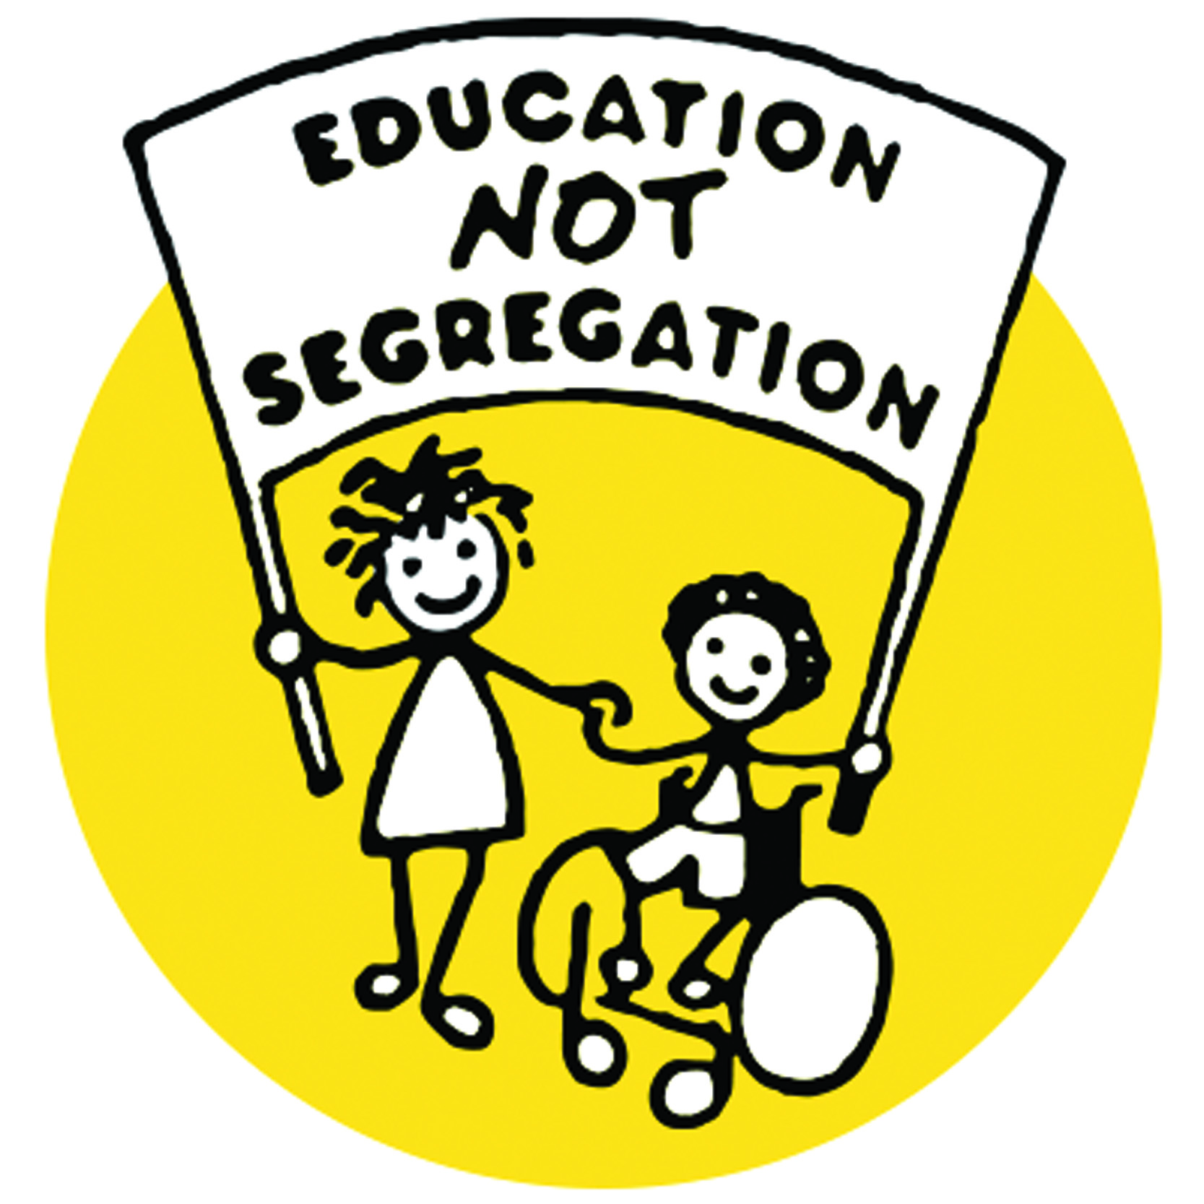
ALLFIE Inclusive Education Election Guide 2019
The general election is fast approaching and, with just a few days to go, the political parties are campaigning for every vote they can secure from us. ALLFIE has set out the Conservative, Liberal Democrat, Labour and Green Party education policies and their approaches to securing disabled pupils’ human rights to inclusive education. We have used ALLFIE’s inclusive education manifesto to highlight what the political parties are proposing to do to promote our six demands if they form the next Government on Friday, 13th December.
 | Green | Labour
Demand No: 1  Human Right to inclusive education | - Retaining the Human Rights Act and disabled people’s ECHR-affirmed right to be educated in mainstream education free from disability-related discrimination.  - Embedding UNCRPD, including Article (24), into UK law.  - Creating a fully inclusive education system by bringing academies and free schools back under local authority control.  - Retaining parental and student choice of special school. Whilst Green Party states that they would develop an inclusive education service, nevertheless this would be compromised by the continuation of special schools. | - Social model of disability included in the Equality Act  - Giving effect to UNCRPD, including Article (24)  - Implementing a National Education Service overseen by local authorities, thus taking control of schools and coordinating admissions.  - All schools will adhere to a common rulebook set out in law.  - Regulating all schools and reform alternative provision.  - Holding schools accountable for pupils they off-rolled to other provisions.  - Whilst the Labour Party will get effect to the UNCRPD it is unclear whether disabled people would have strong rights as there is no explicit legal commitment to inclusive education.
Demand No: 2  Coordinated Education, Health and Care system | - Reducing class sizes to 20 pupils in the long-term to help teachers focus on individual pupil needs.  - Raising funding rates for teaching 16-17 year olds.  - Introducing a capital expansion fund for sixth form providers.  - Introducing a legal right to independent living for disabled people who choose to live independently, overseen by a national Independent Living Support Service.  - Providing an additional £4.5 billion a year to fund councils to provide free social care to people over 65 years of age, to be extended to everyone at a further date.  - Whilst there are specific proposals to increase resources in the education system, nevertheless there is no commitment on how the money will be used to fund coordinated education, health, care and transport services and support for disabled students. | - Implementing a maximum class size of 30 pupils for all primary schools.  - Funding non-contact time with children so that teachers can prepare and plan lessons.  - Providing an £845 million plan for healthy young minds, which will double the annual spending on children and adolescent mental health services?  - Establishing a network of open-access mental health hubs to enable more children to access mental health and recruit almost 3,500 qualified counsellors to guarantee every child access to school counsellors.  - Ensuring the same funding rates for students in Further Education and schools and provide dedicated capital funding to expand existing provisions.  - Joining community and health services, including mental health.  - Providing a National Care Service to provide community based, person-centred support, underpinned by the principles of ethical care and independent living.  - Implementing free care for people over 65 years of age, to be extended to all working-age adults at a further date.  - Whilst there are commitments to have single budget for the funding of health and social care, nevertheless there are no specific proposals to fund coordinated education, health, care and transport services and support for disabled students in educational settings.
Demand No: 3  Inclusive learning environments | - Funding to make schools accessible for disabled pupils, students and staff. | - Making funding available to upgrade schools that have fallen into disrepair. However, no mention of upgrading schools so as to make them fully accessible for disabled people.
Demand No: 4  Inclusive curriculum | - Implementing a broader and more inclusive curriculum, including academic, arts, music, vocational, environmental and sport subjects, as well as for those who are disabled. | - Including black people’s history, the Holocaust and environmental issues but no mention of including disabled people in the curriculum. However there no proposals around an inclusive curriculum that caters for the needs of pupils and students of different abilities and includes representation of disabled people in course topics.
Demand No: 5  Inclusive assessment system | - Freeing schools from centralised testing systems such as SATs, performance league tables and OFSTED’s current inspection framework that have a negative impact upon pupils and students learning. However, there are no proposals around making GCSEs, A Levels and other examination assessment systems inclusive of disabled pupils and students. | - Replacing OFSTED and transferring responsibility for inspections to a new body designed to drive school improvements without specific mention of inspecting inclusive education practice.  - Scrapping Key Stage 1 and 2 and baseline testing and instead focusing on assessments of pupil progress. Whilst scrapping national SATs should mean an end to teaching to the test which can have a negative impact upon pupils and students learning, nevertheless, there are no proposals around making GCSEs, A Levels and other examination assessment systems inclusive of disabled pupils and students.
Demand No: 6  Workforce development | - Recruitment of specialist SEND teachers in all schools. However, there are no specific proposals of inclusive education practice training for the workforce. | - Recruiting nearly 150,000 additional early years’ staff, including Special Educational Needs Co-ordinators. However, there is no explicit proposal to provide inclusive education practice training for the workforce.

 | Conservative | Liberal Democrat
Demand No: 1  Human Right to inclusive education | - No proposals to change the law or comply with human rights obligations.  - Expanding alternative school provision and school placements for children with complex SEN.  - Promoting parental choice.  - Backing head teachers in their use of exclusion for children with “bad” behaviour.  - No specific proposals to change the law other than to increase segregated education whilst making it easier for heads to exclude disabled pupils and students. | - No proposals to change the law or comply with human rights obligations.  - Changing local authorities into local strategic education authorities that will have responsibilities for new school spaces, the power to open community schools and the power to plan school places, exclusions, administration admissions, including in-year admissions, and SEND functions.  - Schools will have a statutory duty to promote the wellbeing of their pupils as part of the inspection framework.  - Whilst there is a commitment for schools to promote pupils wellbeing in schools, this new right will not provide disabled pupils and student a right to inclusive education.
Demand No: 2  Coordinated education, health and care system | - Primary and secondary schools will receive a minimum of £4,000 and £5,000 per pupil.  - Providing £780 million in additional funding for SEND provision during the 2020-21 financial years.  - Raising starting salaries for teachers to £30,000.  - Whilst social care is a priority for the older generation, there are no specific proposals of funding education, health, care and transport services and support for disabled pupils and students in education. | - Reversing the cuts and employing 20,000 extra teachers.  - Limiting classroom sizes to 27 pupils.  - Allocating additional cash to local authorities to halve the amount that schools pay towards the cost of a child’s EHCP.  - Ensuring schools provide immediate access for pupil support and counselling.  - Raising starting salaries for teachers to £30,000.  - Investing £1 billion in Further Education.  - Requiring all universities to make mental health services accessible to their students, and introducing a students’ mental health charter through legislation.  - Raising £7 billion as a result of a 1% increase in income tax for ring-fenced joined up health and care budgets and services.  - Whilst there is emphasis on mental health for children in schools, it does not cover the wide range of other services and support disabled pupils and students need in education. For example no mention of funding of physio, speech and language therapy and transport as well as social care for disabled pupils and students in education.
Demand No: 3  Inclusive learning environments | - No proposed policy. | - Clearing the backlog of repairs to school and college buildings. No policy on updating buildings to make them accessible to disabled people.
Demand No: 4  Inclusive curriculum | - Providing additional funding for enrichment activities outside the core academic curriculum.  - However there are no proposals to extend the “national” curriculum to include non-academic subjects and an inclusive curriculum that caters for the needs of pupils and students of different abilities and includes representation of disabled people in course topics. | - Implementing an independent body of curriculum experts to oversee changes in the curriculum.  - Introducing a ‘curriculum for life’ covering personal, social and health education, financial literacy, environmental issues, first aid and life-saving measures and mental health education. However, there are no proposals around an inclusive curriculum that caters for the needs of pupils and students of different abilities and includes representation of disabled people in course curriculum and a broader range of course subjects.
Demand No: 5  Inclusive assessment system | - OFSTED’s role will remain unchanged.  - Performance league tables and SATs will also continue to be the same.  - No proposals to introduce inspection of inclusive education practise in schools and colleges.  - Whilst there is nothing new, there are no proposals around making the school inspection frameworks, performance league tables and GCSEs, A Levels and other examination assessment systems inclusive of disabled pupils and students. | - Scrapping SATs and replacing them with formal moderated teacher assessment and lighter-touch testing.  - Replacing performance league tables with a broader set of indicators, including information about the wellbeing of pupils and teachers, as well as academic attainment.  - Ensuring the curriculum includes arts and creative subjects and abolishing the EBAC performance measure.  - Whilst these initiatives around school evaluation process may become more inclusive of all pupils achievements, nevertheless there are no proposals to introduce inspection of inclusive education practice in schools and colleges or making GCSEs, A Levels and other examination assessment systems inclusive of disabled pupils and students.
Demand No: 6  Workforce development | - No specific proposals that include inclusive education practice training for the workforce. | - Introducing 50 hours of Continuous Professional Development per year from 2025.  - Providing extra training for secondary school teachers teaching subjects they do not have post-A Level qualifications in.  - Ensuring teachers receive training in how to identify mental health issues in children.  - Verifying that schools, colleges and universities receive training in mental health and adding a requirement for mental health first aiders in health and safety first aid regulations  - However, there is no explicit proposal to provide include inclusive education practice training for the workforce that will cover disability including mental health.

ALLFIE is disappointed that, despite the UNCRPD monitoring committee finding the Government to be in violation of disabled pupils and students human rights to inclusive education, as well as all of the political parties acknowledging that there is a crisis in SEND funding and provision, none of them have a creditable plan that would create a fully inclusive education system that welcomes all. None of the political parties are proposing to enact legislation to secure national inclusive life-long learning, not to mention disabled pupils’ rights to be given the support they require to learn in a fully accessible learning environment in which the curriculum and assessment arrangements are fully inclusive and taught by trained staff committed to inclusive education practices.
What is worrying is that none of the political parties have articulated how they would reverse the ideological bias towards segregated education by moving the funding from alternative provision and special to mainstream schools and colleges so that they can implement inclusive education practice. This includes none of the Parties mentioning how they will fund co-ordinated services to stop the different Departments passing the buck in supporting inclusive education, which is one of the current issues for Disabled pupils and students and families.

